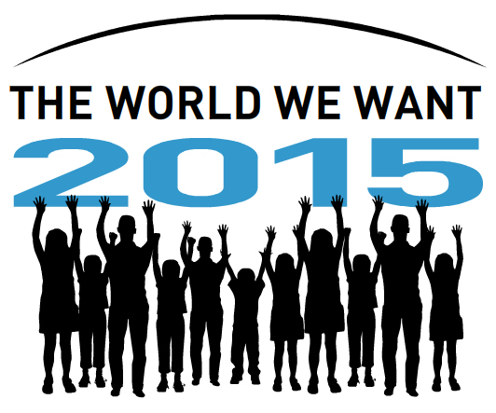

No more talking – it is time for action!

Governments must be accountable to the citizens of the world and fulfill internationally agreed commitments to end poverty.

Leaders from 189 countries adopted the Millennium Declaration in 2000, setting out eight clear cut time-bound commitments to end poverty. Despite some progress and achievements, with just five years to go to the deadline, the MDGS are way off track. While the global financial and climate crises have resulted in an increase in poverty since 2001, at the same time Government commitments to act and to fund have been watered down or broken all together. Only a breakthrough plan can now enable the MDGs to be achieved by the 2015 deadline.

Collectively through our organizations, spanning all continents of the world we have been actively engaged with the MDGs over the past ten years. We were encouraged when UN Secretary General Ban Ki -moon called the UN family to an MDG Review Summit for “a comprehensive review of successes, best practices and lessons learned, obstacles and gaps, challenges and opportunities, leading to concrete strategies for action.”

One week before the summit, we are extremely discouraged by the Outcome Document of the summit, which is the result of four months of negotiations between Government representatives. The negotiations reflected a struggle between developing countries demanding funding, developed countries attempting to avoid actually putting up committed funds and many Member states attempting to avoid living up to their human rights obligations.

The result is a document that ultimately fails to deliver concrete plans to deliver the MDGs by 2015.

It is morally unacceptable that with just five years to the deadline there is such a lack of urgency and political will to fulfill internationally agreed promises to the billions of people all over the world who continue to live in poverty.

No more Talking, Time for Action!

We expect Governments to deliver concrete plans of action to meet and exceed the MDGs and urge them during the Review Summit in New York to ensure:

- The full enjoyment of women’s human rights

Member States must work to end discrimination against women. Gender equality must be mainstreamed into every MDG, and the absence of equal treatment for women and girls should be viewed as a human rights violation. While the Secretary General’s Global Strategy on Women and Children’s Health is particularly welcome, if this plan is to succeed not only must it be fully funded but it must also address the issues of social inclusion, gender equality and the empowerment of women.

- Participation of the most excluded and marginalised populations in development and achieving the MDGs

Member States and the UN System must commit to tracking the progress of those living in poverty and ensure that all poverty reduction strategies programmes include and reach socially excluded and marginalized populations.

- Full and Fair Employment for all

Member States must work to ensure that decent work underpins all the MDGs, providing more and better jobs, social protection, fundamental rights at work and social dialogue. The ILO Global Jobs Pact sets out how these objectives can be realised.

- Accountability

Member states must create an open, robust, credible, transparent and inclusive monitoring and accountability framework at the global and national levels. The framework must consolidate global commitments related to the MDGs, bind them to deadlines and include monitoring and enforcing mechanisms. Civil society must be recognized as an active stakeholder within the framework.

- Quality and Affordable Public Services
The reference to universal access to public and social services and to the provision of social protection floors in the Outcome Document is encouraging, and we call on Member States to agree to putting in place fully funded national plans to achieve universal access to health, water and sanitation, and no -fee education for all.

- Financial, fiscal and economic justice

Member States must fulfill existing funding commitments immediately and increase their ODA to 0.7 % of GDP. They must also create an additional funding mechanism, such as a financial transaction tax (FTT) which would accelerate achievement of the MDGs in areas of full and productive employment, providing resources for social protection, essential services, and the financing needs of developing countries in climate mitigation and adaptation.

- Climate Justice, food sovereignty and food security

Member states must develop credible plans to end the scandal of nearly 1 billion people going hungry every day. They must do this by massively scaling-up investment in agriculture and social protection policies in favour of the poorest farmers and in particular women. This investment must focus on low-input climate-resilient sustainable agriculture and on helping farmers to adapt to impacts of climate change.

Climate finance must be new and additional to ODA. Cannibalising existing aid flows to provide climate finance means that those living in poverty will lose access to schools, clinics and essential services. Asking them to pay for climate action is morally unacceptable.

For more information please contact Fionuala Cregan, Mobilisation Coordinator of the Global Call to Action Against Poverty (GCAP) fionuala.cregan@whiteband.org

Resolution A/64/L.36 submitted by the President of the UN General Assembly on the Organization of the High-level Plenary Meeting of the sixty-fifth session of the General Assembly

